RC tutorial 005 - Alignment with cant - Alignment Coordinate System
========================================================
Revised 2022-11-14
- This tutorial's goal is to teach you the Alignment Coordinate System concept. There is much to read this time! We also touch on Lua formulas in alignments.
- Assumed RailCOMPLETE skills: Previous lessons.
- Assumed railway skills: You know about railway geometry, vertical profile, cant (superelevation), and right-handed coordinate systems.
- Time to spend here: Intermediate: 1 hour. Beginner: 2-3 hours.
- Suggested reading: “2021-05-23_001 EN Introduction to RailCOMPLETE v2021.0”, which can be downloaded from our web pages.
- Notice to users with non-English versions of AutoCAD – see footnote.
- This tutorial was prepared using software release 2022.2.0.8 with Norwegian DNA version “NO-BN 2021.a (patch 1)”,” 2021-11-27T21:11:27+01:00;2021.a”.

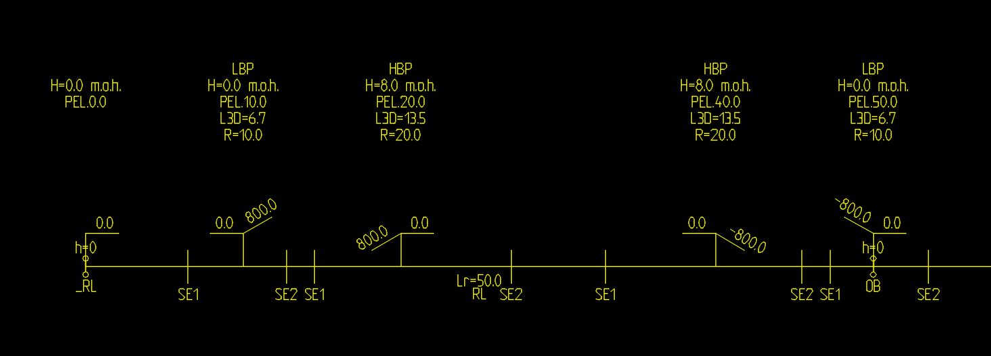
- Start AutoCAD with RailCOMPLETE, then open the ‘National Tutorials’ folder and locate the DWG file named after this tutorial. You can either type RC-OpenNationalTutorialsFolder or you can locate the button below the RC logo in the upper left corner of your AutoCAD window. There are two DWG files – one is the start of the tutorial, the other shows the state you shall have reached at the end of the tutorial.
- The RailCOMPLETE definitions for the Bane NOR network assets measure most lengths in meters and use decimal degrees for presenting angular measures. Cant (superelevation) is measured in millimeters, according to the LandXML 1.2 definitions for metric projects.
NOTE: Some alignment design packages express cant in meters or other units. You may have to scale cant upon importing or exporting alignments with cant data. If you are interested, search for “LandXML 1.2 XSD”.
- Exercise your skills - draw the alignment from scratch, these are the parameters to use:
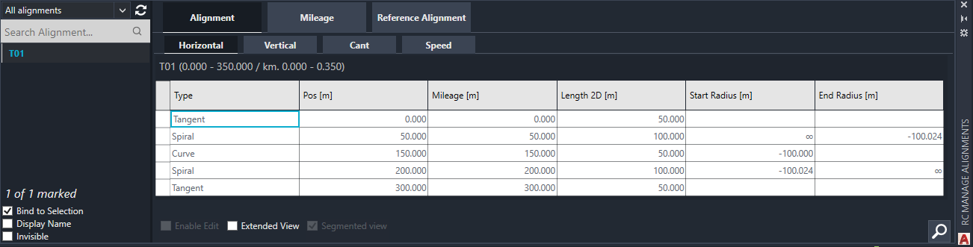
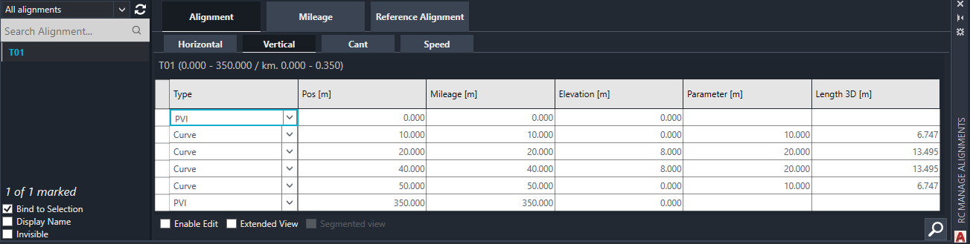
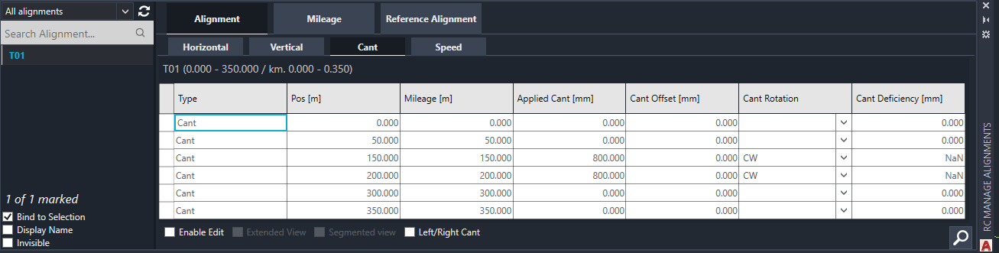
- You will also find the alignment as a LandXML file in the Tutorial’s folder. Import the initial track plan state, as alignment type “JBTKO_SPO Spor”.
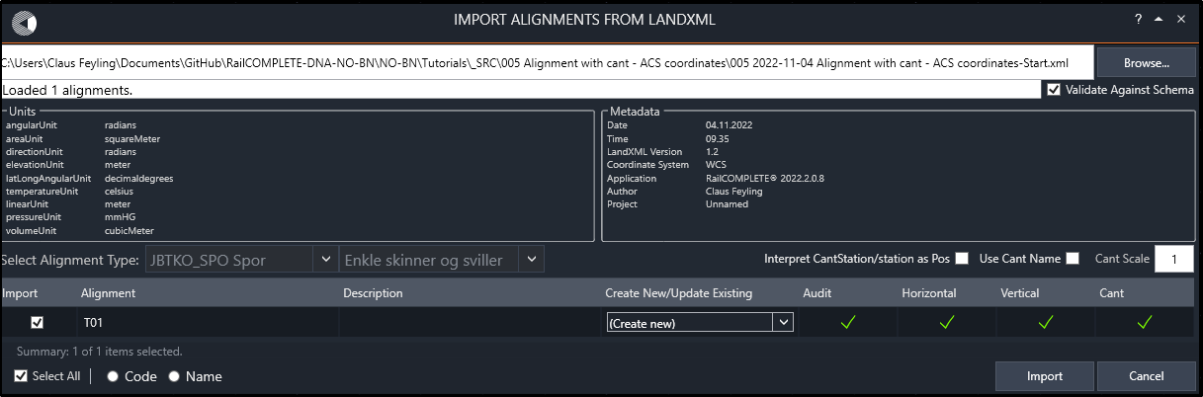
- Revert to the DWG file. Delete any annotations for geometry and vertical profile. Then show the track in 3D, copy it to the drawing, and switch to ‘Shaded with edges’ rendering. You should see this:
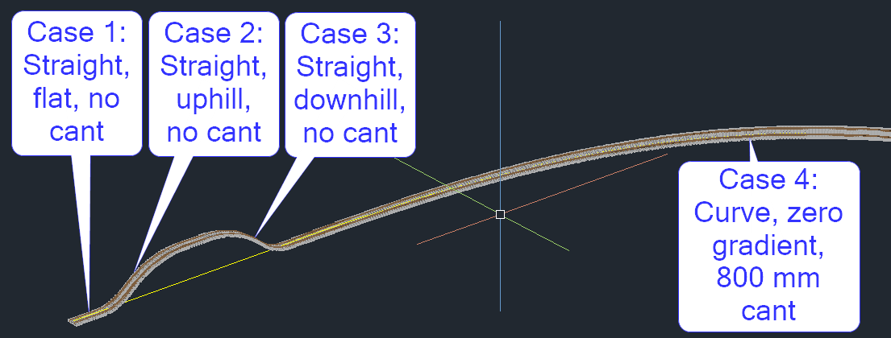
In the following, you will illustrate the Alignment Coordinate System (ACS) in those four different situations.
- Case 1: Straight line, zero gradient, no cant.
Insert a “Hairpin” marker object that you will find under the tab for general objects in command RC-CreatePointObject, then activate the RC-ShowOwnAlignment tool.
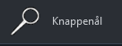
With most installations, double-clicking a point object will open the property manager, or start it with command RC-ManageProperties. Make sure that your editor is showing intrinsic property names and not in the DNA’s local language, socalled ‘display names’ – change this setting in the RC-Settings tool.
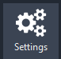 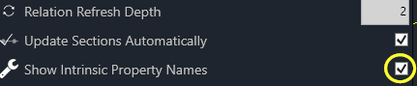
Click the small icon in the top left corner of the property manager to change the amount of information shown. Click the angle bracket to the left of each category’s row to open/close it.
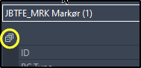 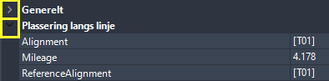
Depending on your color settings, the angle bracket for an open category is block and rather hard to see – sorry about that.
Now open the RC-ManageProperties tool’s “Plassering langs linje” (Linear placement) category and move the hairpin to Mileage = 5 by selecting the hairpin and changing the Mileage property to ‘5’.
Select the hairpin again, then delete its RelativeElevation formula and then change its relative elevation to 2 meters above the track. To delete a property’s formula, just click its cell and then press Delete. You may alternatively press Shift+Delete to remove the formula and to reset the property’s value in one operation. You may round a number to the nearest integer using Ctrl+Shift+Spacebar. Another way to remove a formula is to open the formula editor (F3), delete the contents, then Save and Close.
Change the object’s Mileage up and down a few meters, then change its relative elevation up and down. Delete the formula for DistanceToAlignment and change its distance to alignment to ‘-3’, which means 3 meters to the left of the alignment’s center line.
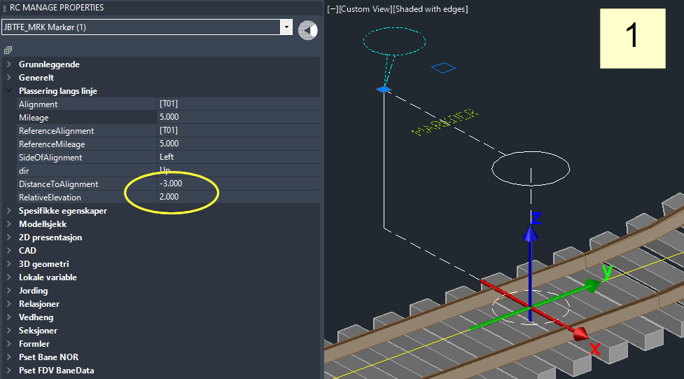
Notice that the XYZ axis system that appears once the object is selected. This is the ACS at the object’s current position. The red X-axis points to the right, perpendicularly to the alignment’s direction in the XY plane. The Y axis points in the direction of the alignment’s direction. The Z axis always points “straight up”, aligned with the World Coordinate Z axis.
ACS coordinate | Corresponding RailCOMPLETE property
X | DistanceToAlignment
Y | LongitudinalOffset
Z | RelativeElevation
Navigation tip:
The user interface in RailCOMPLETE will in many cases allow you to alter a number using the wheel on your mouse in combination with the Ctrl, Alt and Shift buttons on your keyboard. The default step size is 1.
Also note that most numeric input cells accept Lua code, i.e., you may enter any mathematical expression directly, such as ‘25+20’ to change a Mileage from 25 to 45, etc.
Key combination | Step size
Ctrl + Alt + mouse wheel | 100
Alt + mouse wheel | 10
mouse wheel | 1
Ctrl + mouse wheel | 0.1
Ctrl + Shift + mouse wheel | 0.01
Shift + mouse wheel | 0.001
Ctrl + Shift + Spacebar | Snap to nearest integer value
- Case 2: Straight line, increasing gradient, no cant.
Let DistanceToAlignment be -3. Let RelativeElevation be +2. Set Mileage to 15, which is the “Case 2” position as indicated in this document’s first illustration.
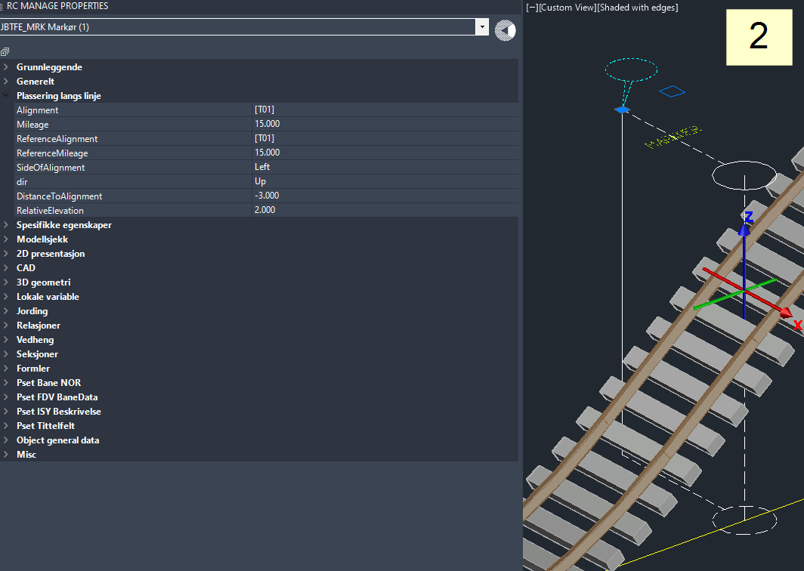
- Case 3: Straight line, decreasing gradient, no cant.
DistanceToAlignment = -3. RelativeElevation = +2. Set Mileage to 45, where there is a steep downhill gradient. Note that the Y axis is coplanar with the World Coordinate System’s XY plane, also if you change the User Coordinate System (command UCS). In other words, gradient does not affect the ACS.
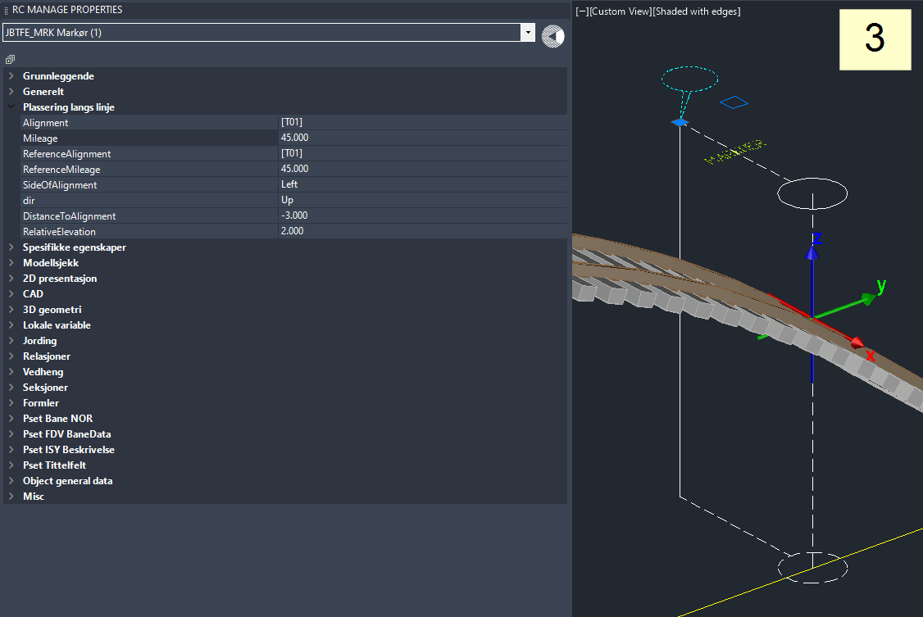
- Case 4: Right-handed curve, zero gradient, significant cant (superelevation), Mileage = 180. Note that the X axis is coplanar with the World Coordinate System’s XY plane, also if you change the User Coordinate System (command UCS). In other words, cant does not affect the ACS.
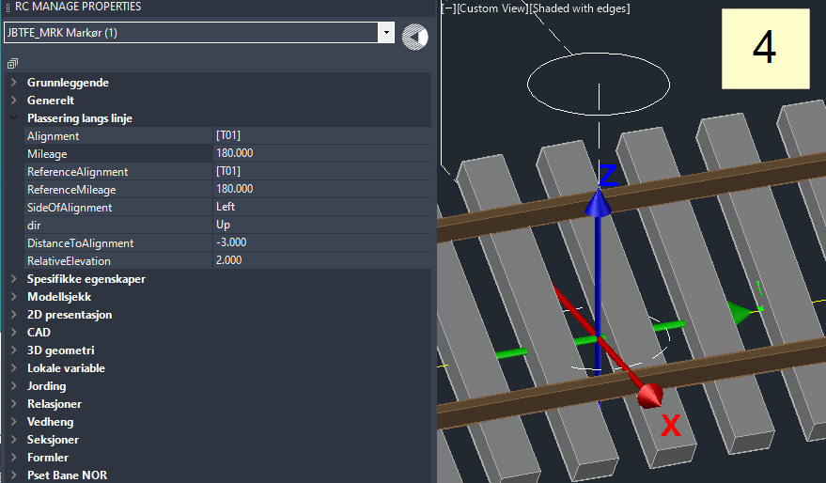

Further reading
- RC-RotateUcsAndView
According to current DNA settings, AutoCAD operates by default in a Cartesian XYZ World Coordinate System (WCS) set to meter [m] unit for each axis, North is 90 degrees and ‘up’, East is 0 degrees and ‘right’. Positive direction of rotation is from East towards North.
To express your object's coordinates in another Cartesian X'Y'Z' User Coordinate System (UCS), use AutoCAD command UCS to set the new origin and axis directions, then use PLAN or EXPLAN to rotate your view so the X' axis points straight right on your screen. A more convenient way for RC users is to right-click, select ‘RailCOMPLETE Rotate UCS and View’ or run command RC-RotateUcsAndView, then click twice to give a direction on your screen which will represent oyur new horizontal-towards-the-right on your computer screen. Using RC-RotateUcsAndView also resets your VIEW to ‘Top’.
- geoCoord
Point objects possess a property called ‘geoCoord’, inherited from the railML standard. The RailCOMPLETE Property Manager always shows geoCoord XYZ as WCS coordinates – Easting, Northing, Elevation above mean sea level:
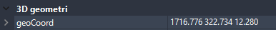
- Right-handed ACS
Hint: Imagine that "Y" is your right-hand index finger which is pointing along the alignment in the increasing mileage direction, and "Z" is your right-hand middle finger pointing straight up. Then "X" is your right-hand thumb, pointing to the right side of the alignment. This is the right-handed ACS.
- In the RailCOMPLETE Property Manager, Object Manager and Alignment Manager, basic mileage values are expressed in meters (not kilometers).

Lua coding for alignments – a sneak-peek
- Select the alignment T01, open the Property Manager, then open the 3D tab and the Offset3D subtab for one of the 3D representations of type “iterated Model 3D”. Make sure it is switched ON (sunshine=Thawed, not snowflake=Frozen).
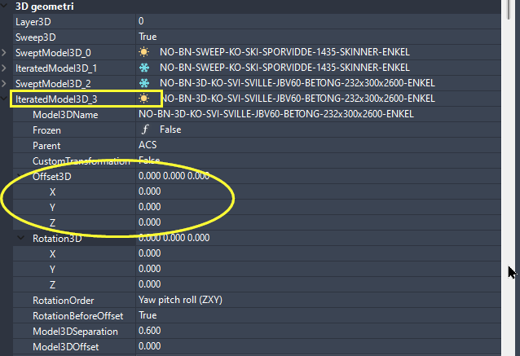
Select the Xoffset3D.X cell, then press F3 to bring up the Lua editor. Enter the following formula:
10 * math.cos(3 * 2 * math.pi * _position.Pos / RcAlignment.HorizontalProfile.Length)
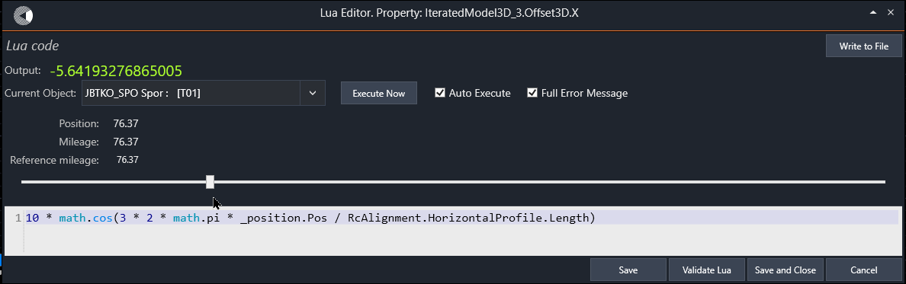
The ‘_position.Pos’ slider in the Lua alignment editor is a continuous and strictly increasing distance measure along the alignment's horizontal geometry (a 2D curve in the XY plane), a kind of “cursor” that runs from start to end of the geometry. Play with the slider in the Lua alignment editor at the Offset3D.X property and see that the output is a sine wave.
As long as the property ‘CustomTransformation’ is False, then RC will use its internal machinery when converting the alignment’s geometry, vertical profile and cant profile into 3D rendering.
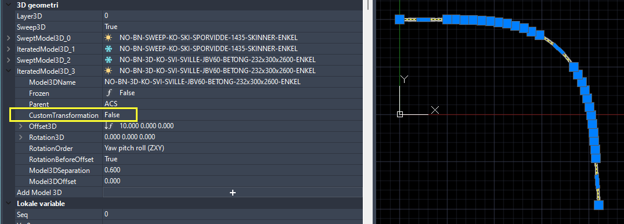
Set property ‘CustomTransformation’ to True and preview the 3D graphics again. Now the custom formulas for Offset3D and Rotation3D take effect, producing a 3-period sine wave of peek-to-peek amplitude +/-10 in the ACS X coordinate:
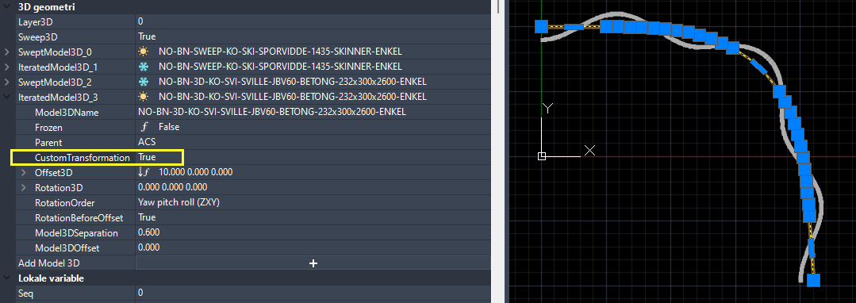

Cant
- With most railway administrations, the cant, or superelevation, is measured as a vertical uplift of one top-of-rail in relation to the other, expressed in milllimeters [mm]. Cant is basically a signed angle expressing a sleeper’s rotation about the local alignment axis (roll) using the horizontal XY plane as a reference.
For historical and for practical reasons, cant is measured using a water level device and reading the vertical distance between the two top-of-rails. There is a standard reference cant gauge associated with each track gauge, for conversion of cant between millimeters and angle. For normal gauge tracks (1432..1438 mm between the two wheel/rail contact points), the standardized cant gauge reference value is 1.5 m. That is, sin(alpha) = h/1500 for normal gauge tracks, where h = cant in millimeters and alpha is the cant angle. The sign of the cant angle is also subject to interpretation. Most track design software packages interpret ‘clockwise cant rotation’ as a positive rotation about the ACS y-axis. Wider gauges use 1600 mm or more as a cant gauge track reference, see the literature on this.

Alignment System, 3D offset and 3D rotation
- Select the alignment T01 again, open the Properties Manager’s ‘Alignment’ tab and select the AlignmentSystem row. It should read “Normalspor 1435 mm”, which is the standard for mainline railway in Norway.
Click to the left of that row to expand it, and you will see the properties CantGauge (1.5) and AlignmentGauge (1.435). The CantGauge value is used when converting cant between millimeters and angles. The AlignmentGauge is used when placing objects such as axle counters or track joint isolations in rails, or when expressing the rail/wheel contact lines in 3D. As cant increases, the two rails in a railway track alignment will creep towards the alignment axis (as seen from above), without moving the track sideways.
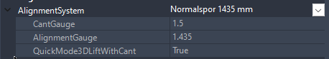
- Various alignment systems are defined in the DNA. Speak to your local RC agent if you miss one. Some alignment systems – platform edges, for instance – have 0 as CantGauge. RailCOMPLETE must then interpret the Cant value appropriately, as encoded in its DNA.
- The last property in the alignment system, QuickMode3DLiftWithCant, is used by RailCOMPLETE when converting an alignment object into 3D graphics. Some administrations interpret cant as a mere rotation about the alignment axis, but most administrations interpret the cant as a rotation and an upwards translation by half the cant in millimeters. The result is that the lowest rail is always level with the alignment axis Z(s)-value.
- If an alignment is expressed in 3D with its CustomTransformation property set to False, then RailCOMPLETE considers that the sleepers shall be lifted with half the cant since the alignment’s AlignmentSystem definition says so. In other words, the 3D Offset Z property (‘Offset3D.Z’ in Lua) is implicitly replaced by the formula “getAlignmentInfo(_position).Cant/2000”, no matter what formula you might have stored for Offset3D.Z yourself.
- When an alignment’s CustomTransformation is set to False, then the Offset3D.X and Offset3D.Y are implicitly set to zero, no matter what formulas you might have stored in them yourself.
- When an alignment’s CustomTransformation is set to False, then the Rotation3D.X, Rotation3D.Y and Rotation3D.Z formulas for iterated 3D models are implicitly set to express the rotations you would expect for an object which is installed in a track, such as a sleeper being repeated for every 60 cm or so.
- For the IteratedModel3D_1 representation of sleepers, adjust the Offset3D and Rotation3D formulas as shown below. These ‘NOBN_...’ formulas are part of the DNA for NO-BN, Bane NOR.
Offset3D
Offset3D.X (lateral) 0
Offset3D.Y (longitudinal) 0
Offset3D.Z (lift=vertical) NOBN_trk_getLiftFromCant(_position)
Rotation3D
Rotation3D.X (pitch) NOBN_trk_getPitchFromGradient(_position)
Rotation3D.Y (roll) NOBN_trk_getRollFromCant(_position)
Rotation3D.Z (yaw) 0
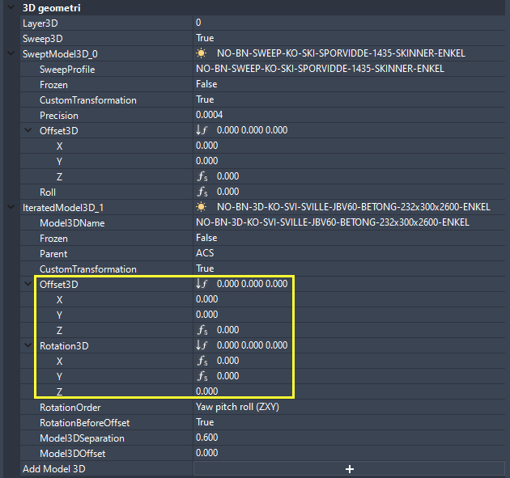
- Note that the order of application of the rotations around the X, Y and Z axes influences the end result. Experiment with the RotationOrder parameter, trying pitch before roll or roll before pitch. Can you see a slight difference? For point objects having directions (such as a track-mounted balise), the Yaw (rotation around Z-axis) is 0 or 180 degres, and should be applied prior to pitch (gradient) and roll (cant), i.e. rotation order ZXY
- Activate the RC-Show3DPreview tool and select the alignment. Play a little with CustomTransformation set to True or to False, with values or formulas that you assign yourself to the Offset3D and Rotation3D. Place your cursor in the property of interest and press F3 to bring up the Lua editor. Hover over the formula and press F5 to obtain a local copy that you can modify at will.
- When cant is applied to an object, be it a top-of-rail line, a balise, an axle counter, a switch or any other track-bound object, then we rotate the object's lateral position (X,Z) around the local ACS Y-axis and then translate it upwards by half the superelevation. In this way, both rails will be slightly moved inwards, and the lowest rail's top-of-rail will remain at the alignment's elevation at that position (i.e. at relative elevation zero). Viewed from the positive Z-axis, adding cant to an alignment this way does not change the geometry.
- Play with the various alignment annotation tools:
RC-ShowAlignmentGeometry
RC-ShowAlignmentProfile
RC-ShowAlignmentMileage
RC-ShowAlignmentName
RC-ShowTwoRails.
- Note: There is no required definition of CW / CCW reference system in the LandXML 1.2 standard, so you may have to flip CW/CCW upon import or export of LandXML files to get things right. Simply set the Cant Scale to ‘-1’ when using RC-ImportAlignmentsFromLandXml.
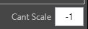
- Note: If we consider an object rotated with its alignment's cant rotation, expressed in ACS, then a positive rotation about the local Y-axis will raise the object’s left side above the right side, as viewed in the direction of increasing mileage.

Please check our website www.railcomplete.com for updates.
Corrections and suggestions are welcome to support@railcomplete.com.
Thank you for using RC Tutorials!

Your AutoCAD session has probably been started from a Windows shortcut of the type: “C:\Program Files\Autodesk\AutoCAD 2022\acad.exe” /product ACAD /language “fr-FR”, where “fr-FR” means “French language, France’s version”, or similar, or no language specified (English is the native language for AutoCAD). Native AutoCAD commands may have different names in your language pack, other than the COPY, COPYBASE, FIND etc that you see in our tutorial texts. In order to instruct AutoCAD to accept the native English command name, precede the native (English) command name by an underscore character, ‘_’. For instance: ‘_FIND’ will start AutoCAD’s native ‘FIND’ command even if you are using AutoCAD with the French language pack, where the command in French is called ‘RECHERCHER’. If a command needs an argument ‘ON’, and the French menu says ‘Allumer’, then you can enter ‘_ON’ to instruct AutoCAD to use the option’s native name. Furthermore, the English AutoCAD object selection prompt (command _SELECT) accepts many keyboard shortcuts such as A = (add) add to selection set, R = (remove) remove from selection set and AL = (all) all objects (and many more). These shortcuts are named differently in other language packs. In French they are for instance A=ajouter, S=supprimer, TO=tout. Consult AutoCAD Help in your native language.
LongitudinalOffset was introduced in 2023. It is zero at the ACS origin. It lets you address coordinates along the ACS Y axis, i.e., extending the alignment’s geometry’s tangent direction up and down from the ACS origin.
In RailCOMPLETE, an AlignmentSystem may have a CantGauge which is zero.

